Final Integration, Evaluation and Reporting
Telco Customer Churn Analysis in Tableau: six weeks from exploration to optimization
Virtual Tableau Visualization Internship (Yuva Intern), Week 6 Task
Prepared by: Madugula Manikumar | 5 October 2026
Repository: github.com/manimadugula03-ui/telco-churn-tableau-eda

Table of Contents
No. | Section | What it covers
1 | Executive Summary | Results, what was built versus planned, main recommendation
2 | Project Overview and Learning Journey | The six weeks at a glance
3 | Exploratory Analysis (Week 1) | Dataset, charts built, first findings
4 | Dashboard Design (Week 2) | Objectives, KPIs, layout, colour code, interactivity plan
5 | Data Narrative (Week 3) | Story concept, six story points, what-if scenario
6 | Advanced Techniques (Week 4) | Heat map, dual-axis chart, Pareto chart, calculated fields
7 | Optimization and Interactivity (Week 5) | Bottlenecks, strategies, filter action
8 | Critical Evaluation | Effect of design decisions on storytelling and performance
9 | Lessons Learned | Technical and process lessons
10 | Recommendations | Business actions and future Tableau enhancements
11 | Challenges and Future Possibilities | Problems met and where the project can go next
12 | Conclusion | Summary of findings and what the process taught
A | Appendix: Calculated Fields and Validation | Formulas and check values
B | Appendix: Repository Contents | Files and where to find them

1. Executive Summary
Over six weeks I analysed the public Telco Customer Churn dataset (7,043 customers, 21 fields) in Tableau Public. I started with exploratory charts, planned a dashboard and a data story, built three advanced charts with calculated fields, and finally assessed and improved the dashboard for performance and interactivity. This report integrates all of that work and reflects on it.

Main findings
- Overall churn is 26.5%: 1,869 of 7,043 customers have left, about one in four.
- Contract type is the strongest pattern: month-to-month churn is 42.7%, against 11.3% for one-year and 2.8% for two-year contracts.
- The highest-risk segment is month-to-month fiber optic: 54.6% churn (1,162 of 2,128 customers). This one segment causes 62.2% of all churn, and with month-to-month DSL it causes 83.3%.
- Churn happens early: 47.4% of customers in their first 12 months churned, falling to 9.5% after 48 months.
- Price is linked to churn: churned customers pay 74.44 per month on average against 61.27 for retained customers.

What was built and what was only planned
Built and tested in Tableau | Planned (documented, not yet built)
Five exploratory charts and Dashboard 1 (Week 1) | Two-page dashboard with KPI cards and Segment Explorer page (Week 2)
Heat map, dual-axis chart and Pareto chart (Week 4) | Tableau Story with six story points and a what-if slider (Week 3)
Five calculated fields, including a table calculation (Week 4) | Quick filters, drill-down hierarchy and metric parameter (Week 5)
Dashboard filter action on the Contract chart (Week 5) | Monthly Revenue at Risk field, LOD benchmarks and dynamic captions (Week 4 plan)

Main recommendation
Focus retention effort on new month-to-month fiber optic customers, particularly in their first 12 months, and encourage them to move to longer contracts. This one group holds most of the churn, so a targeted campaign addresses most of the problem.

2. Project Overview and Learning Journey
Week | Task | Deliverable | Outcome
1 | Exploratory analysis | Five charts, Dashboard 1, report | Found where and for whom churn is highest
2 | Dashboard planning | Design strategy: KPIs, layout, colours, interactivity | Blueprint for a two-page dashboard
3 | Interactive data story | Story concept, six story points, what-if scenario | Narrative from headline to action
4 | Advanced charts and calculations | Heat map, dual-axis, Pareto, calculated fields | Confirmed the highest-risk segment with evidence
5 | Performance and interactivity | Assessment, strategies, filter action | Fixed data connection; tested interactive filter
6 | Final integration | This report | All weeks combined with reflection
The work moved from describing the data (Week 1), to planning how to present it (Weeks 2 and 3), to building and testing advanced techniques (Week 4), to making the result robust and interactive (Week 5). Each week used the same dataset and the same colour code, so the pieces fit together.

3. Exploratory Analysis (Week 1)
Question: Which customers are leaving the company, and what do they have in common?
The data comes from Kaggle (IBM sample data, uploaded by BlastChar). Each row is one customer, with demographics, account information and subscribed services. The target variable is Churn (Yes or No). I chose five variables: Churn, Contract, Tenure, Monthly Charges and Internet Service, and built one chart for each question, with churned customers in orange and retained customers in blue.
Finding | Result | Reading
Overall churn | 26.5% (1,869 of 7,043) | About one customer in four has left
Contract | Month-to-month 42.7%, one year 11.3%, two year 2.8% | No long-term commitment means higher churn
Tenure | Churned 17.98 months, retained 37.57 months on average | Customers leave early
Monthly charges | Churned 74.44, retained 61.27 on average | Higher bills go with higher churn
Internet service | Fiber optic 41.9%, DSL 19.0%, no internet 7.4% | Fiber optic is the risk product

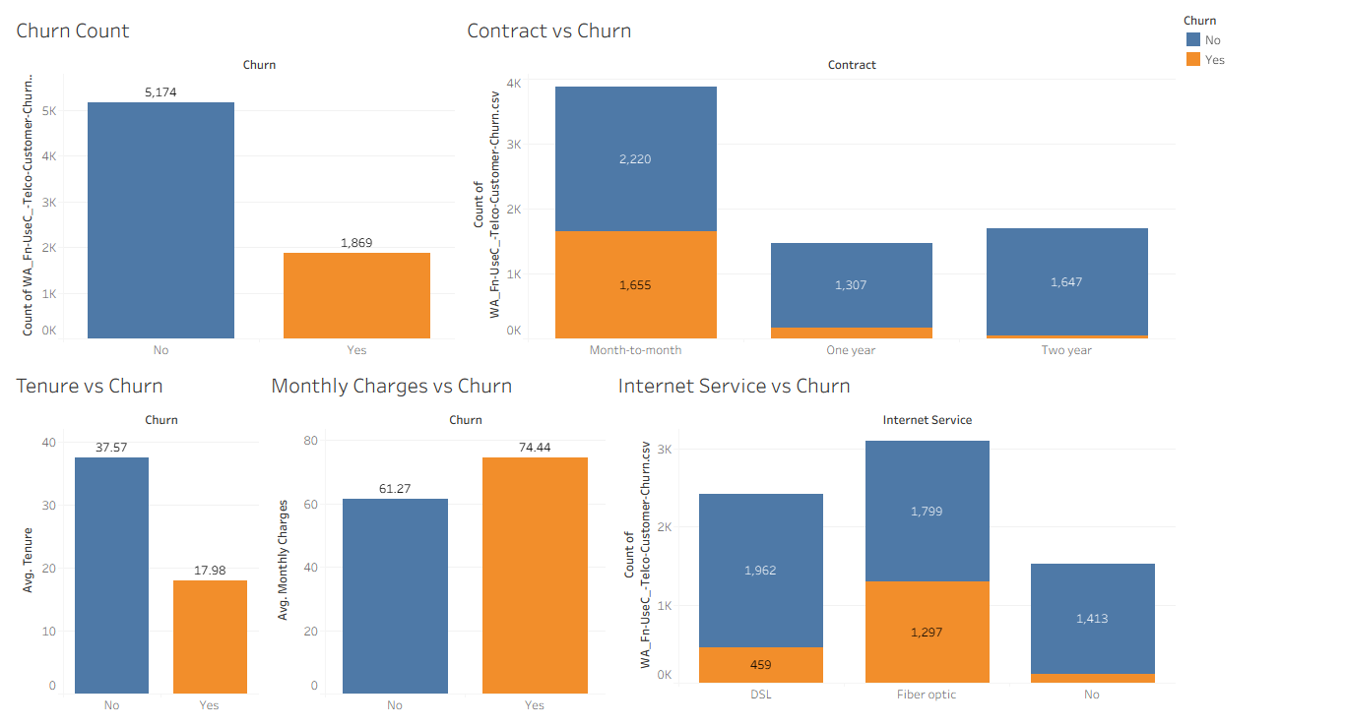
Figure 1: Week 1 churn dashboard built in Tableau Public (five charts)
Limit of this stage: the charts show counts and averages of single variables. They suggested that month-to-month fiber optic customers were at highest risk, but could not confirm it. Weeks 4 and 5 test this.

4. Dashboard Design (Week 2)
Week 2 planned an interactive dashboard so that a manager could see within seconds how many customers are leaving, which segments leave most, and what to do. This stage was a design plan; the final dashboard was not built in that week.
Design element | Decision
Audience | Retention or customer-success manager, pricing and marketing manager, senior management
Business questions | How many churned? Which contract and internet service churn most? How early do customers leave? Do leavers pay more? Which segments to target first?
KPIs | Total customers (7,043), churned customers (1,869), churn rate (26.5%), average tenure of churned customers (about 18 months), average monthly charges of churned customers (74.44), monthly revenue at risk (planned)
Layout | Page 1 Overview: header, filter strip, KPI row, two wide charts for contract and internet service, tenure and charges charts, insights panel. Page 2 Segment Explorer for deeper analysis (progressive disclosure)
Colour code | Orange = churned, blue = retained and counts, navy = headings. The same code is used in every week
Interactivity | Filters (Contract, Internet Service, Tenure Group, Senior Citizen), highlight and filter actions, custom tooltips, navigation to Page 2
The design principle was to put the most important information in the top half of the screen, keep Page 1 simple, and move detail to Page 2. Dashboard 1 in the workbook follows the colour code and the chart choices; the KPI cards, Page 2 and the insights panel remain to be built.

5. Data Narrative (Week 3)
Week 3 planned an interactive data story with the title "Who is leaving, and what can we do about it?". The key message: churn can be reduced by moving month-to-month customers to longer contracts and by protecting new and high-paying customers early.
# | Headline | Visualization | Contribution
1 | 1 in 4 customers is leaving | KPI cards | Hook: the problem is large
2 | Contract type decides who stays | Churn rate by contract | Strongest explanation
3 | Customers leave early | Average tenure, churned vs retained | Adds timing
4 | Higher bills, riskier product | Monthly charges and internet service | Adds price and product
5 | The highest-risk segment | Heat map: contract x internet service | Combines the findings
6 | What if we move customers to longer plans? | Parameter slider with projected churn rate | Resolution: a measurable action
What-if scenario (planned): if a share of month-to-month customers behaved like today's one-year customers, projected churn would fall from 26.5% to about 23.1% when 20% of them are converted (775 customers), and to about 19.6% at 40%. This is a simple scenario that assumes switchers behave like current one-year customers; it shows the size of the opportunity and is not a forecast.
Story point 5 asked for a heat map to confirm the highest-risk segment. That is exactly what Week 4 built.

6. Advanced Techniques (Week 4)
Week 4 built three advanced charts in Tableau and the calculated fields behind them. I selected them from a longer list (box plot, bullet chart, treemap and bump chart were rejected because the data or question did not fit).

6.1 Heat map: where is churn highest?
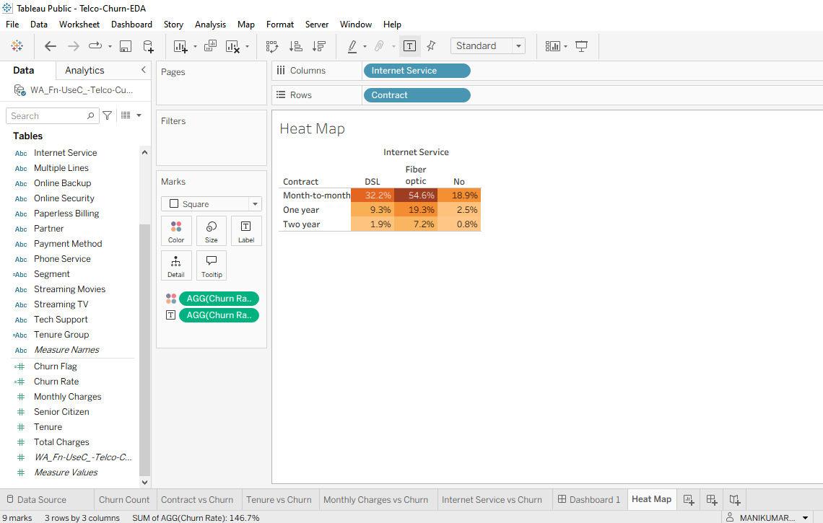
Figure 2: Churn rate by contract and internet service (Tableau)
Month-to-month fiber optic has the darkest cell, 54.6% churn (1,162 of 2,128 customers). Fiber optic has the highest churn in every contract row, and churn falls with longer contracts in every column. This confirmed the Week 1 and Week 3 hypothesis.

6.2 Dual-axis chart: when does churn happen?
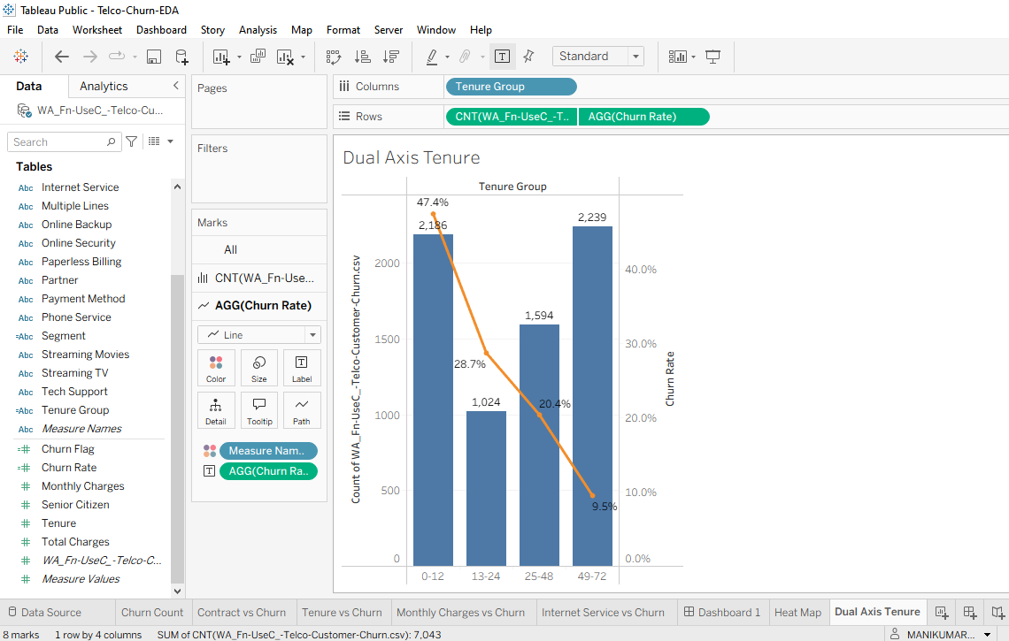
Figure 3: Customers (bars) and churn rate (line) by tenure group (Tableau)
Churn is 47.4% in the first 12 months, then 28.7%, 20.4% and 9.5%. The first group is also one of the largest (2,186 customers), so the early period is both risky and large.

6.3 Pareto chart: which segments matter most?
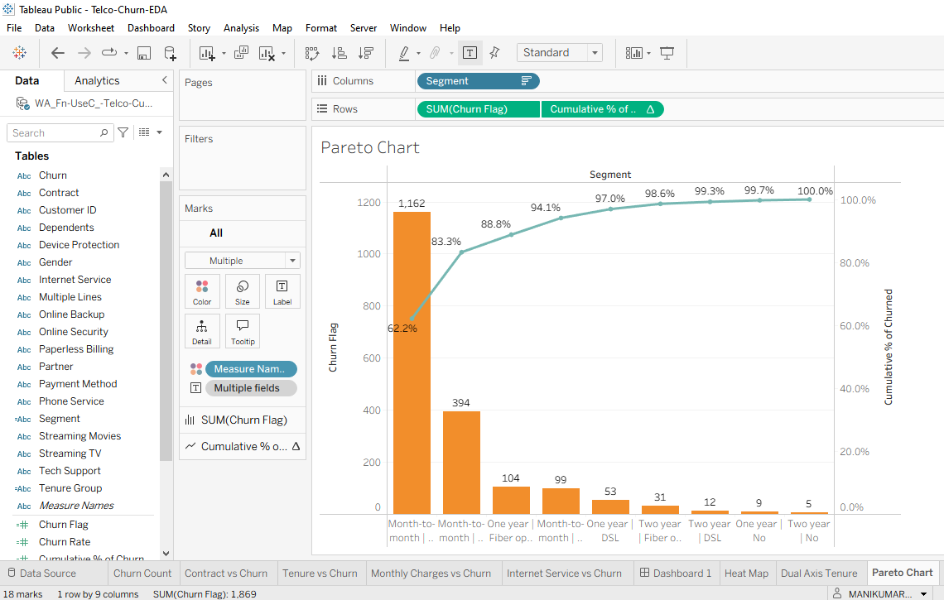
Figure 4: Churned customers by segment with cumulative percentage (Tableau)
Month-to-month fiber optic causes 62.2% of all churn (1,162 of 1,869); adding month-to-month DSL gives 83.3%. The other seven segments together cause 16.7%.

6.4 Calculated fields
Field | Type | Formula
Churn Flag | Row-level | IF [Churn] = "Yes" THEN 1 ELSE 0 END
Churn Rate | Aggregate | SUM([Churn Flag]) / COUNT([Customer ID])
Tenure Group | Row-level | IF [Tenure] <= 12 THEN "0-12" ELSEIF [Tenure] <= 24 THEN "13-24" ELSEIF [Tenure] <= 48 THEN "25-48" ELSE "49-72" END
Segment | Row-level | [Contract] + " | " + [Internet Service]
Cumulative % of Churned | Table calculation | RUNNING_SUM(SUM([Churn Flag])) / TOTAL(SUM([Churn Flag]))

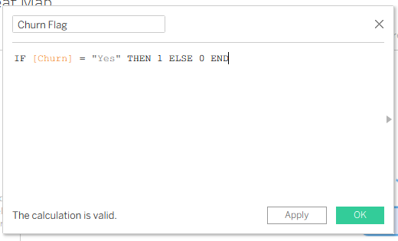
Figure 5: Churn Flag in Tableau, confirmed as a valid calculation
A problem I found: my first Pareto chart was sorted alphabetically, so the cumulative line was meaningless (0.3% at the first bar, 78.9% at the eighth). The values were right but the order was wrong. Sorting by the Churn Flag field in descending order fixed it. This showed that a table calculation is only as correct as its sort and Compute Using setting.

7. Optimization and Interactivity (Week 5)
Week 5 assessed the dashboard for performance and added interactivity. Tableau Public cannot record load times, so the assessment is based on inspecting the real workbook, not on timings.
Bottleneck | Evidence and fix
Data connection and packaging | The workbook referenced the CSV by file path; when the file location changed, Tableau asked "Where is the data file?" and showed no data. A hidden double extension (.csv.csv) was the cause. Fix: reconnect the file (done), rename it, and save as a packaged workbook (.twbx, recommended)
Unused fields | The dashboard uses 6 of 21 columns. Recommended: hide the other 15 and use an aggregated extract
Calculations | Row-level text calculations and a sort-dependent table calculation. Recommended: prepare text fields upstream and document the sort
Dashboard design | Automatic size shifts the layout. Recommended: a fixed size such as 1200 x 800
Interactive feature built: I turned on "Use as Filter" for the Contract chart. Clicking the Month-to-month bar filtered every other chart: 3,875 customers (2,220 retained, 1,655 churned), with 1,162 churned on fiber optic and 394 on DSL. These values match the Pareto chart and the heat map, so the interaction is consistent with the Week 4 analysis.
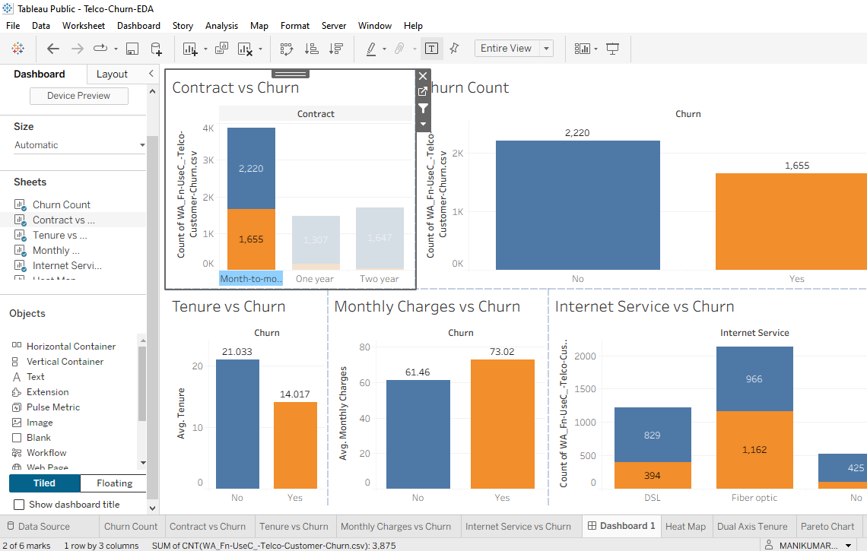
Figure 6: Dashboard 1 after clicking the Month-to-month bar (Tableau)
Further interactive features (quick filters, a drill-down hierarchy and a metric parameter) are documented with build steps but not yet built.

8. Critical Evaluation
This section judges how effective my approaches were and how my design decisions affected data storytelling and performance.
Decision | Effect on storytelling | Effect on performance and usability | Evaluation
One colour code in every chart (orange = churn, blue = retained) | The viewer never relearns the legend; Weeks 1 to 6 read as one story | None | Worked well
Counts and averages in Week 1 | Showed that churn matters, but large groups looked worse simply because they were large | Light and fast | Useful start, replaced by rates in Week 4
Churn Rate calculated field | Compares groups of different sizes fairly; made the 54.6% result possible | Small cost | High impact
Heat map for two variables | Points the eye to the single darkest cell | One chart replaces nine bars | Worked well
Dual axis for volume and rate | Shows size and risk together | One sheet instead of two | Worked well; axes must be labelled
Pareto chart | Shows concentration of churn in two segments | Depends on sort and Compute Using | High value, needs care
Aggregated sheets (2 to 6 marks each) | Clear, uncluttered charts | Fast drawing at any data size | Worked well
Filter action instead of filter cards | One click answers one question across all charts | Fewer controls and queries | Worked well
Planning first (Weeks 2 and 3) | Gave a clear narrative and KPI list | None | Good, but a plan is not evidence until built
Overall: the strongest decisions were rates over counts, a consistent colour code, and aggregated charts. The weakest point was relying on plans and mock-ups before building and testing, which I address in Section 9.

9. Lessons Learned

Technical lessons
- Use rates, not counts, to compare groups of different sizes.
- A table calculation depends on sort order and addressing. Always check the first and last values against an independent calculation.
- A workbook that points to an external file breaks when the file moves. Save as a packaged workbook (.twbx) and keep the file name simple; turn on Windows file extensions to avoid names like .csv.csv.
- Calculated fields must be built and tested in Tableau, not only written down. A formula that looks right on paper can still need fixing.
- Tableau Public has limits (no Performance Recording), so some conclusions must be framed as design analysis, not measurement.

Process lessons
- Evidence matters more than plans. My first Week 4 submission used mock-up figures, described calculations in the future tense and was not in my GitHub repository. It was returned for lacking specific techniques and evidence. I rebuilt it from real Tableau screenshots, tested every formula, validated the numbers against values calculated separately from the CSV, and added the report to GitHub. The resubmitted work was far stronger.
- Validate numbers twice: once in Tableau and once independently, for example with pandas.
- Keep the deliverables, the workbook and the data together in one repository so that every claim can be checked.
- Say clearly what was built and what was only planned. This makes the report trustworthy.

10. Recommendations

Business recommendations (from the data)
- Target month-to-month fiber optic customers first. They hold 62.2% of all churn and churn at 54.6%.
- Strengthen the first 12 months. Churn is 47.4% in that period; onboarding support and early-retention offers should be the first actions. In the dataset, month-to-month fiber optic customers in their first 12 months (916 customers) churn at 70.2%, a precise first target.
- Encourage longer contracts. The what-if scenario suggests that converting 20% of month-to-month customers could lower overall churn from 26.5% to about 23.1%, as an illustration, not a forecast.
- Review fiber optic pricing and value. Fiber optic churn is high and churned customers pay more per month. This is a hypothesis to test, because the data shows association, not cause.
- Track revenue at risk. Calculated from the dataset, churned customers account for 139,130.85 per month, 30.5% of monthly charges, about 72% of it from month-to-month fiber optic customers. This figure is verified in the data but not yet built as a Tableau field.

Recommendations for future Tableau work
Enhancement | Value
Build the two-page dashboard (KPI cards, Segment Explorer) at a fixed size | Turns the Week 2 plan into a usable product
Build the Tableau Story with the what-if parameter | Delivers the Week 3 narrative interactively
Add quick filters, a drill-down hierarchy and a metric parameter | Lets viewers explore without extra charts
Add Monthly Revenue at Risk, an overall churn benchmark (FIXED LOD) and dynamic captions | Links churn to money and keeps text in step with the data
Save as .twbx, hide unused fields, use an aggregated extract | Portable, smaller and faster workbook
Measure load and click response with Performance Recording in Tableau Desktop | Replaces design estimates with real timings
Add a date field or customer history if available | Allows trend analysis and bump or time-series charts

11. Challenges and Future Possibilities

Challenges I met
- Connecting the data: Tableau first opened a wrong, missing data source; I had to connect the CSV as a text file. Later the data file moved and had a hidden double extension.
- Building advanced charts: the dual-axis colours came out reversed, and the Pareto sort was wrong until I used Sort By Field.
- Evidence and time: Week 4 had to be rebuilt after it was returned, under a tight deadline.

Future possibilities
The segments found here (new month-to-month fiber optic customers) can feed a predictive churn model, and the dashboard can become a live monitoring tool if refreshed with new data. With a date field, the same charts could show whether retention actions are working over time. A published Tableau Public version would let others explore the story themselves.

12. Conclusion
In six weeks I moved from basic charts to advanced calculations and an interactive, more robust dashboard on one dataset. The analysis shows where churn is concentrated (month-to-month fiber optic, 54.6%), when it happens (the first 12 months, 47.4%) and how concentrated it is (two segments cause 83.3%). Just as important, the process taught me that every claim needs evidence: charts built in the tool, formulas tested, numbers validated twice, and files in a repository anyone can open. The plans from Weeks 2 and 3 and the recommendations from Weeks 4 and 5 give a clear path for the next stage of this project.

Appendix A: Calculated Fields and Validation
Check | Expected (pandas) | Shown in Tableau | Match
SUM(Churn Flag) | 1,869 | 1,869 | Yes
Tenure groups: customers | 2,186 / 1,024 / 1,594 / 2,239 | 2,186 / 1,024 / 1,594 / 2,239 | Yes
Tenure groups: churn rate | 47.4 / 28.7 / 20.4 / 9.5% | 47.4 / 28.7 / 20.4 / 9.5% | Yes
Heat map, Month-to-month row | 32.2 / 54.6 / 18.9% | 32.2 / 54.6 / 18.9% | Yes
Pareto bars | 1,162, 394, 104, 99, 53, 31, 12, 9, 5 | Same | Yes
Pareto cumulative % | 62.2, 83.3, 88.8, 94.1, 97.0, 98.6, 99.3, 99.7, 100 | Same | Yes
Filter action: Month-to-month customers | 3,875 (2,220 + 1,655) | 3,875 (2,220 + 1,655) | Yes

Appendix B: Repository Contents
File | Content
Telco-Churn-EDA-Report.docx | Week 1: exploratory analysis report
Dashboard-Planning-Design-Strategy.docx | Week 2: dashboard plan and design strategy
Interactive-Data-Story-Plan.docx | Week 3: data story plan
Week4-Advanced-Charts-and-Calculations.docx | Week 4: advanced charts and calculated fields
Week5-Performance-Optimization-and-Interactivity.docx | Week 5: performance assessment and interactivity
Week6-Final-Integration-Evaluation-Report.docx | Week 6: this final integration report
Telco-Churn-EDA.twb | Tableau workbook (all sheets and Dashboard 1)
WA_Fn-UseC_-Telco-Customer-Churn.csv.csv | Dataset
README.md, dashboard image | Project overview and dashboard preview

